Press release

Dazzling carbon footprint for Gebrüder Weiss
Logistics services provider improves energy efficiency thanks to LED solution by Zumtobel

Environmental and climate protection have long been an integral part of Gebrüder Weiss' corporate philosophy: thanks to the TECTON LED continuous-row system solution provided by Zumtobel, the international transport and logistics company has been able to reduce CO2 emissions related to lighting at its freight hub in Pöchlarn by nearly two thirds. Furthermore, the solution is perfectly suited for industrial applications and, due to its low-maintenance design and the LED light sources' long service life, contributes to increasing sustainability.

Dornbirn, October 2014 – Gebrüder Weiss, one of Europe's most important transport and logistics services providers based in Lauterach, Vorarlberg, continues its long-standing collaboration with Zumtobel: at the company's Pöchlarn site, the conventional fluorescent tubes installed in a loading and unloading hall with a floor space of some 2,250 square metres have been replaced by a modular TECTON LED continuous-row system solution provided by Zumtobel.

Due to their high energy efficiency, LEDs have played a major role in building new and refurbishing existing buildings of the logistics hubs of Gebrüder Weiss in compliance with environmental considerations. For the Pöchlarn refurbishment project, it was however not only for environmental but also for functional and economic reasons that the decision-makers opted for TECTON LED: “We were looking for a solution suitable for an industrial application which we could use as a basic system and flexibly adjust to a variety of standard specifications for illuminating different areas of the hall,” outlines Markus Nigsch, head of real-estate and facility management at Gebrüder Weiss, the most important requirements. For example, it should be no problem to install presence detectors. Above all, one of the arguments in favour of the Zumtobel system were the low maintenance efforts required, as the design of the continuous row system and the trunking follows the principle of plug and play. Tools are neither required for connecting trunking elements nor for replacing luminaires. The significantly extended maintenance cycle of the solution is also due to the LEDs' long service life of an average of ten years.

Markus Nigsch underlines the direct impact of TECTON LED on the CO2 footprint of the Pöchlarn freight hub by making a direct comparison with the discarded fluorescent lamp solution: “We have been able to reduce annual power consumption from 1.2 million to less than 465,000 kilowatt hours. This results in a reduction of CO2 emissions related to lighting by almost 139 tonnes per year – amounting to just 38.6 per cent of the former level.”

Similarly positive results were achieved with LED solutions provided by Zumtobel also in large-scale projects of Gebrüder Weiss regarding new buildings – for instance at the Wels logistics centre, at the Jeneč site in the Czech Republic, and in the new warehouse and head office at the company's headquarters in Lauterach. Other projects are already in the pipeline.

About Gebrüder Weiss
Gebrüder Weiss Holding AG is, on the one hand, the joint holding company of the three main business units inland transport, air and sea cargo and logistics. On the other hand, the holding company brings together a wide range of industry-related special services provided by a variety of subsidiaries – among them logistics consulting, high-tech and software solutions, e.g. for transport management, as well as call centre and telemarketing services. Owing to its consistently environmentally and socially responsible corporate philosophy, the family enterprise, which looks back on a history of more than five centuries, is today considered a pioneer in the field of sustainable business. Gebrüder Weiss employs a workforce of some 6000 people at 150 locations. In 2013 the group achieved annual sales of EUR 1.2 billion.

Captions:
(Photo credits: Zumtobel)
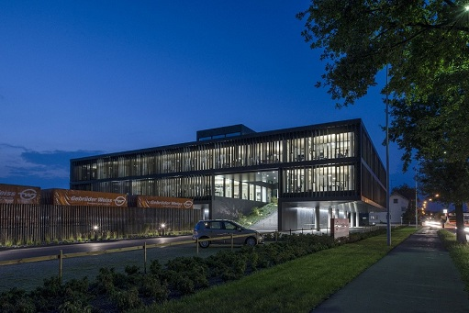
Fig. 1: Gebrüder Weiss, one of Europe's most important transport and logistics services providers based in Lauterach, Vorarlberg, continues its long-standing collaboration with Zumtobel.

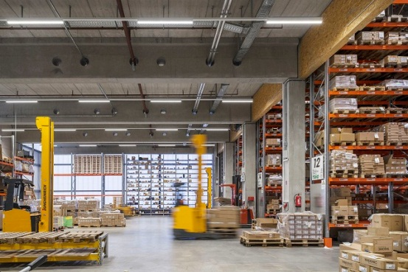

Fig. 2: Due to their high energy efficiency, LEDs have played a major role in building new and refurbishing existing buildings of the logistics hubs of Gebrüder Weiss in compliance with environmental considerations.

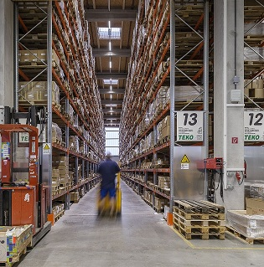
Fig. 3: Thanks to the TECTON LED continuous-row system solution provided by Zumtobel, the international transport and logistics company was able to reduce CO2 emissions at its freight hub in Pöchlarn by nearly two thirds.

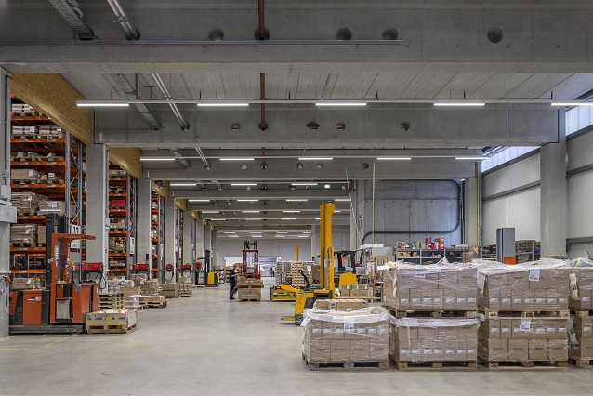

Fig. 4: Annual power consumption could be reduced from 1.2 million to less than 465,000 kilowatt hours. This means a reduction in CO2 emissions related to lighting by almost 139 tonnes per year – amounting to just 38.6 per cent of the former level.

Press contact:
Zumtobel Lighting GmbH  Sophie Moser  PR Manager  Schweizer Strasse 30  A-6851 Dornbirn  Tel.: +43-5572-390-26527  Mobile; +43-664-80892-3074  e-mail: sophie.moser@zumtobelgroup.com  www.zumtobel.com | ZG Zumtobel Lighting GmbH  Daniel Lechner  Director Marketing Austria  Donau-City-Strasse 1  A-1220 Vienna  Tel +43 (1) 258 26 01 82875  Fax +43 (1) 258 26 01 982875  E-mail daniel.lechner@zumtobelgroup.com  www.zumtobel.at

About Zumtobel
Zumtobel, a leading international supplier of integral lighting solutions, enables people to experience the interplay of light and architecture. As a leader in innovation, Zumtobel provides a comprehensive range of high-quality luminaires and lighting management systems for professional interior lighting in the areas of offices, education, presentation & retail, hotel & wellness, health, art & culture as well as industry. Zumtobel is a brand of Zumtobel AG with its head office in Dornbirn, Vorarlberg (Austria).
Zumtobel. The Light.

