Press release

Optimum lighting for engine research
“Centre for Mobile Propulsion” fitted with flexible lighting solution by Zumtobel

The new engine research centre “Center for mobile Propulsion” (CMP) of Aachen University of Technology (RWTH) is a contemporary multi-functional building complex designed by the Cologne-based architects' studio of Lepel & Lepel. For this ambitious architectural project, the Austrian luminaire manufacturer Zumtobel has implemented a lighting design concept developed by a·g Licht that meets the highest demands in terms of design and efficiency.

Dornbirn, May 2014 – Computer-aided research and studies on hot engines: the perfect solution to the problem of combining these two different task areas under one roof has been provided by the Cologne-based architects Lepel & Lepel for the “Center for Mobile Propulsion” of RWTH Aachen. The building complex includes a seminar and administration building as well as a test rig hall for engines. Here, engineers and scientists study the theory and practice of new propulsion technologies and optimised performance of engines for passenger cars and utility vehicles. Both buildings serve the same purpose of research, but have different functions – which is also reflected by their architecture: the seminar and administration building has an open and inviting feel with its curved form and soft lines, featuring glazed panels and flexible room layouts inside. In contrast, the test rig hall has been designed as a closed, solid structure made of dark exposed concrete with narrow windows and ventilation slits. Here the engines are tested in compliance with high safety standards and strict technical requirements out of the public eye. Although the two buildings stand in stark contrast in terms of design, they complement each other subtly in terms of functions. The waste heat produced during the engine test runs, for instance, is used for heating the seminar building. The construction's sustainability is also demonstrated by the high levels of daylight available in both buildings, which allows for predominantly natural lighting of the working environment, enhances the staff's sense of well-being and saves energy costs.

In order to provide supplementary illumination with artificial lighting, the Cologne-based architects and the lighting designers of a·g Licht from Bonn developed an individual solution for each building. According to the requirements, perfect task lighting with high lighting quality had to be ensured. At the same time, the lighting and the architecture had to form a harmonious ensemble. Zumtobel was responsible for implementing the concept and managed to win the customer over thanks to the company's international experience, premium advisory skills and wide range of products.
In the foyer of the administration building, the lighting solution expert has installed LINARIA decorative luminaires. They provide ideal lighting conditions to facilitate orientation and guidance and enhance the room's architecture thanks to their extremely slim design. In the offices and seminar rooms, Zumtobel has fitted 420 ECOOS luminaires arranged in continuous rows. The individual luminaires have been positioned one after the other to form narrow light lines without any visible fittings or connectors. Thanks to direct, indirect and lateral light components, ECOOS ensures efficient lighting for the workstations and also provides vertical illumination. This improves the staff's visual comfort and concentration while bright ceilings and walls create a pleasant room atmosphere. ECOOS also allows for quick and easy installation. In this way, the lighting system can be smoothly adjusted to new room layouts. “ECOOS could not fail to impress us thanks to its high flexibility, minimalist design, brilliant optic and extremely large direct/indirect light component,” says architect Reinhard Lepel. “In addition, the luminaire boasts lower operating costs than other luminaires, so that the investment will pay for itself within a short period.”
In the engine test rig hall, the efficient TECTON continuous-row lighting system meets all requirements placed on optimum lighting of workstations and perfect orientation even from large heights. Some 400 TECTON luminaires have been installed in this area. They can be positioned flexibly, and the system can be adjusted to changes in room layout at any time. TECTON is a continuous row system mounted on trunking that incorporates all luminaire modules and a current conducting section. Only the lighting modules, light sources or optics are replaced or added, if required. This allows quick expansion and adjustment of the lighting solution and reduces installation times and maintenance costs. This is a major asset especially in those areas of the hall that are difficult to access.

Facts & figures on the Zumtobel products used
ECOOS  http://www.zumtobel.com/ECOOS | Individual luminaire or continuous row system for indirect, direct and lateral lighting using only one light source; the direct component is guided via MPO+ technology; DALI-dimmable; dimensions: 1207 x 120 x 80 mm; weight: 2.92 kg
LINARIA  http://www.zumtobel.com/LINARIA | Batten luminaire or continuous row system without any visible fittings or connectors for consistent light lines with uniform brightness; extremely slim design; surface mounting or pendant mounting possible; DALI-dimmable
TECTON  http://www.zumtobel.com/TECTON | Continuous-row lighting system with trunking that integrates power supply, lighting control and connection to emergency lighting; four different optics; perfect light direction; optionally available with daylight-based control, presence detectors or motion sensors

Captions:

(Photo credits: Zumtobel)

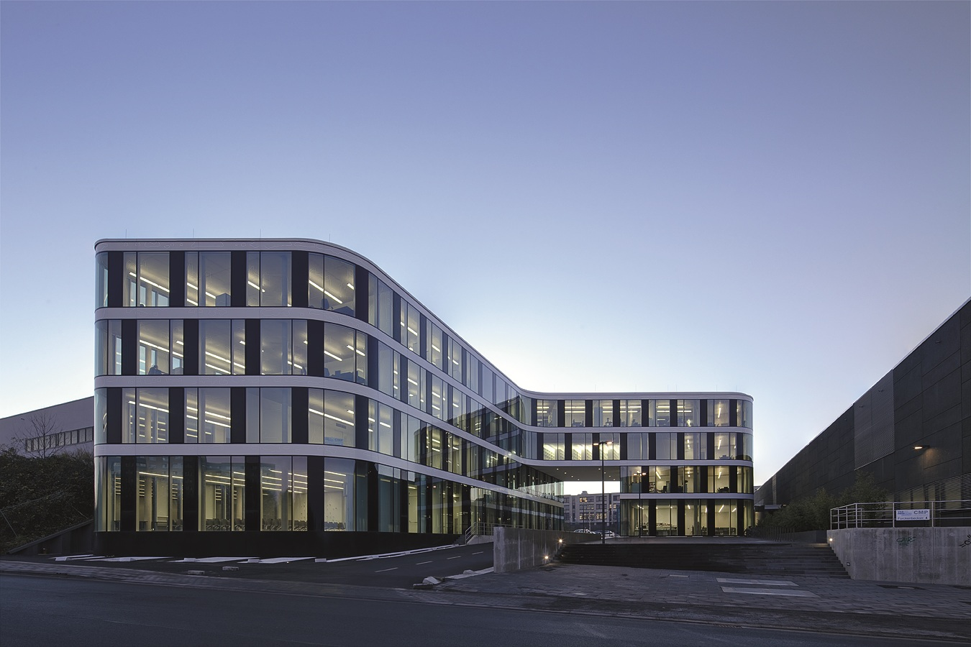

Caption 1: For the new engine research centre of Aachen University of Technology (RWTH), the “Center for Mobile Propulsion” (CMP), Zumtobel has implemented a lighting design concept developed by a.g. Licht.

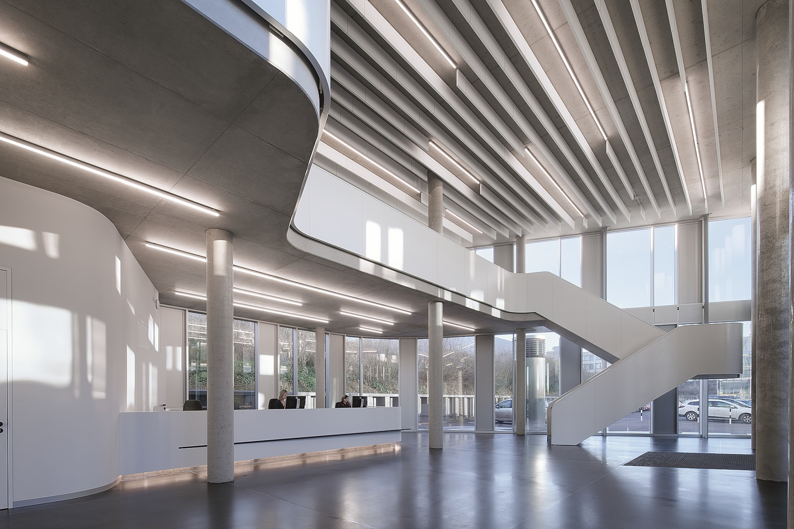

Caption 2: LINARIA luminaires provide ideal lighting conditions to facilitate orientation and guidance and enhance the room's architecture thanks to their extremely slim design.

Press contact:
Zumtobel Lighting GmbH
Sophie Moser
PR Manager
Schweizer Strasse 30
A-6851 Dornbirn

Tel +43-5572-390-26527
Mobile +43-664-80892-3074
E-mail sophie.moser@zumtobel.com

www.zumtobel.com

About Zumtobel
Zumtobel, a leading international supplier of integral lighting solutions, enables people to experience the interplay of light and architecture. As a leader in innovation, Zumtobel provides a comprehensive range of high-quality luminaires and lighting management systems for professional interior lighting in the areas of offices, education, presentation & retail, hotel & wellness, health, art & culture as well as industry. Zumtobel is a brand of Zumtobel AG with its head office in Dornbirn, Vorarlberg (Austria).
Zumtobel. The Light.

