Press information

Zumtobel ensures unique customer experience and lets designer store shine in new light
Gustav Bruynseraede has fulfilled a lifelong ambition with his single-label boutique on the “Eiermarkt” in the historic centre of the Belgian town of Antwerp. This is where the distinctive collections of the Issey Miyake brand have been exclusively showcased since September 2015. The design of the shop proved to be a major challenge. On the one hand, every aspect of the plans, including the LED lighting solution from Zumtobel, had to meet the strict requirements of the Tokyo-based fashion brand. On the other hand, the issue of historic preservation placed the emphasis firmly on improvisation, as the 300-square-metre venue is housed in a building from the 16th century. No fresh incursions into the ceiling were allowed, so the new luminaires had to be installed in the spaces used for the previous lighting solution.
Dornbirn, May 2016 – The hard work has definitely paid off for Gustav Bruynseraede. He has always been fascinated by the unique technoid style of Issey Miyake. The Japanese clothing designer and founder of the fashion brand that bears his name is regarded as a true visionary, drawing inspiration from art, architecture and the people he meets. Like no one else before him, Issey Miyake is able to seamlessly combine tradition and innovation, purity and colour, nature and culture, artistic craftwork and advanced technology. Even though he is no longer involved in the day-to-day operational business, Issey Miyake still insists on approving the new designs and defining the brand identity.
Unique shopping experience
The Issey Miyake store presents itself as a shining jewel from outside. A charming contrast is formed by juxtaposing the historic facade with the straight lines of the glass frontage and the modern passageway that leads through to the courtyard. Purism and transparency dominate the interior. This effect is further enhanced by the custom-made furniture crafted using white concrete and sand-blasted glass. This is where the miniaturised MICROTOOLS modular LED lighting system accentuates specific items and features. Enthralling lighting effects designed to follow a subtle dramatic scheme draw attention to the store, creating a feel-good atmosphere and helping extend the amount of time that the customer is likely to spend browsing.
Even the shop window presents itself as a showroom. Dynamic light with various brightness levels gives the impression that the distinctive Issey Miyake mannequins are actually moving. Each dummy is highlighted by a pair of accent spotlights from the INTRO lighting system, which is fitted flush into the ceiling. One spotlight with a focused distribution and one with floodlight characteristics offer the optimal combination. This vibrant show attracts the attention of passers-by and draws them into the store, where the same staging concept – albeit somewhat less theatrically – puts the "catwalk" mannequins centre stage.
The white frameless driver modules of the INTRO system fit adroitly into the ceiling, helping simultaneously to ensure sufficient general lighting and to focus attention on the latest collections. Here the dramatic effects differ significantly from conventional lighting solutions. The shop is divided into several zones, which use a network of motion sensors to respond interactively to customer movement in the store with subtle changes in the brightness levels. In this way, customers are escorted by gently dynamic light from the entrance all the way through the clearly defined areas of the world of Issey Miyake. A warm welcome is thereby unconsciously conveyed, raising the likelihood of people spending more time in the store and leading to greater consumer enthusiasm.
The design of the four changing rooms, finished off with four round PANOS infinity downlights, invite customers to try on the designer items. The warm-toned ambient lighting is normally dimmed to 50% luminous flux. When a customer enters this area, a motion sensor detects movement and the lighting solution is adjusted accordingly, creating a feel-good atmosphere. The flattering lighting scenario is further enhanced in the hallway area with the mirrored wall. Square PANOS infinity downlights with tunableWhite technology and an EMOTION touch panel were specifically selected to markedly enhance the retail experience. Sales consultants can use the panel to adjust the brightness and colour temperature of the light to suit different items or to show certain pieces of clothing in a particular light. This ensures the natural presentation of materials and colours. In addition, the panel can be used to select a series of pre-programmed scenes for different situations, such as customer events.
The key to retail success
The consumer experience is playing an increasingly important role when it comes to both achieving success in the retail sector and convincingly expressing a particular brand message. Dutch scientist and artistic engineer Luuk van Laake, founder of the company digiluce, translated store owner Gustav Bruynseraede's initial vision for the lighting arrangement into a conceptual design, crucially adding the element of interaction. This plan was then further refined and finally implemented by the Zumtobel team in Belgium.
It was vitally important to present the materiality and colour of the various collections in an expressive manner – for which the INTRO lighting system with TGRfashion technology is perfectly designed. The LED spotlights are characterised by an exceptionally good colour rendering of Ra = 95, which means that white, bright and also richer hues appear with exceptional quality and brilliance. Contrasting material properties are also clearly differentiated by the TGRfashion spotlights. The added value of this solution is clearly illustrated by comparing original garments displayed in light from TGRfashion technology with those items classically illuminated with a uniform 3000 K colour temperature solution – which immediately impressed shop owner Gustav Bruynseraede.
The LED lighting solution from Zumtobel also scores highly when it comes to energy efficiency and lower heat transfer. Compared to the previous low-voltage halogen installation that Gustav Bruynseraede had used for the former multi-brand XSO designer store, the new lighting solution has a reduction of energy consumption of around 70 percent.. This excellent energy saving potential does not yet even take dimming or factors such as the night-time scene into account, which delivers the same dynamic lighting effects with a lower brightness level, ensuring that the authentic image of the Issey Miyake store is perfectly showcased at all times.
The optimal blend of TGRfashion technology, a dynamic LED lighting solution and outstanding energy efficiency meets the high demands of Issey Miyake and was a key factor in helping Gustav Bruynseraede put his faith in the INTRO, PANOS infinity and MICROTOOLS lighting systems from Zumtobel.

Photo captions:
(Photo credits: Zumtobel)
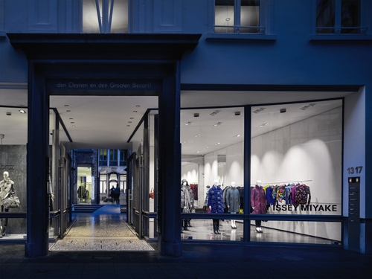
Image 1: The shop window presents itself as a showroom. Dynamic light with various brightness levels gives the impression that the distinctive Issey Miyake mannequins are actually moving.
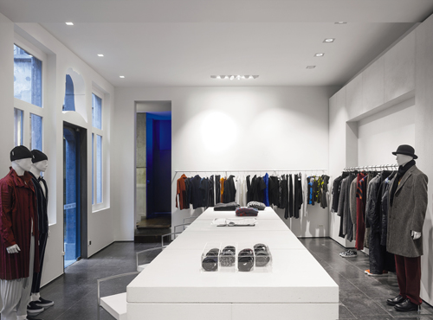
Image 2: The white driver modules of the INTRO system fit adroitly into the ceiling, helping to ensure sufficient general lighting and to focus attention on the latest collections.

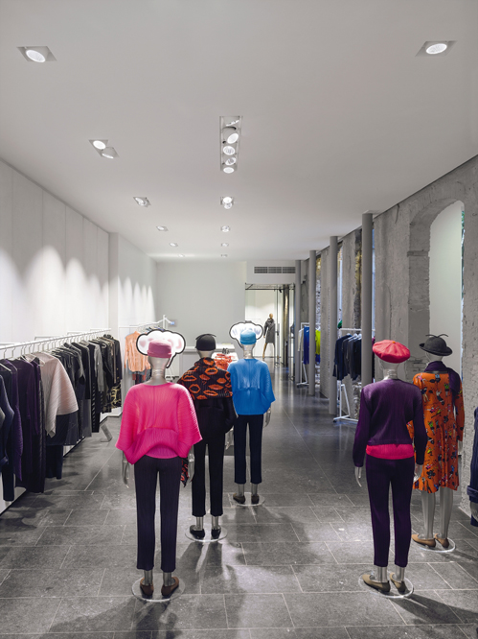
Image 3: Each dummy is highlighted by a pair of accent spotlights from the INTRO lighting system, which is fitted flush into the ceiling. One spotlight with a focused distribution and one with floodlight characteristics offer the optimal combination.
Press contact:
Zumtobel Lighting GmbH  Andreas Reimann  Brand PR Manager  Schweizer Strasse 30  6850 Dornbirn  Austria  Phone: +43 5572 390 26522  press.zumtobel@zumtobelgroup.com  www.zumtobel.com | Zumtobel Group  Jennifer Sewell  Marketing Communications Manager  Chiltern Park, Chiltern Hill  Chalfont St Peter, Buckinghamshire SL9 9FG  United Kingdom  Phone: +44 0 7785 232 294  jennifer.sewell@zumtobelgroup.com  www.zumtobel.com
Zumtobel Lighting Inc.
Donna Fischer
Marketing Manager Americas
Zumtobel Lighting US
3300 Route 9W
Highland, NY 12528
Phone: +1 845-691-6262 - 7611
donna.fischer@zumtobelgroup.com
www.zumtobel.us

About Zumtobel
As a leader in innovation, Zumtobel develops sustainable lighting solutions tailored to the needs of people in their respective applications. With a comprehensive portfolio of high-quality luminaires and intelligent lighting management systems, the Austrian company provides optimum indoor and exterior products for working and living spaces - the right light for every activity at any time of day. The applications office, education, presentation and retail, hotel and wellness, health, art and culture and industry are now perfectly complemented with portfolios for living and outdoor areas. Zumtobel is a brand of Zumtobel Group AG with its head office in Dornbirn, Vorarlberg (Austria).
Zumtobel. The Light.

