Press release

arlberg1800 art and concert hall shines with lighting from Zumtobel
The recently opened arlberg1800 Contemporary Art and Concert Hall in St. Christoph has already delighted many visitors with a series of concerts and events. A customised LED lighting solution from Zumtobel has put the focus firmly on the art, culture and architecture of this fascinating new venue.
Dornbirn, December 2015 – Nestled in the Arlberg mountain range, most of the 1000-square-metre space for art, culture and creative work can be found underground. The architecture of Jürgen Kitzmüller is in tune with nature and draws heavily on a reduced design language. “The spaces first exert their effect with the right light," explains Jürgen Kitzmüller. With a clear emphasis on fundamental elements, the architecture of Europe's highest contemporary art and concert venue is both flexible and modern. The wood-panelled concert hall is specially designed to offer excellent acoustics through the integration of curved walls with in front of cavities.
The lighting solution from Zumtobel simultaneously showcases the architecture and meets the various requirements associated with an art and concert venue. "Zumtobel brought its long-standing experience of cultural projects from around the world. This knowledge and the overall professionalism were valuable assets for a project that has even broken new ground for ourselves," reports Florian Werner, owner and managing director of the arlberg1800 RESORT. As the owner, Florian Werner set himself a new challenge with this cultural project, showing tremendous dedication to guarantee the optimum technical and aesthetic realisation of his vision. A customised LED lighting solution was designed for the various different rooms and spaces to make sure that the lighting concept was fully in line with this approach.
Special luminaire for a customised LED lighting solution
A unique new luminaire was developed specifically for the art gallery. Bright warm white LED light lines traversed by a cold white light shaft in the floor and ceiling underline the effect of the 9-metre-high room and perfectly capture the essence of its material character. The VIVO LED spotlight system demonstrates its flexibility by delivering direct illumination in the art gallery and other rooms. The precise and uniform light distribution and excellent colour rendering are ideal for highlighting particular works of art and creating the right lighting effects for concerts and events. While more functional luminaires provide orientation and a pleasant ambience in the entrance and hallways, the SCONFINE decorative pendant designed by Matteo Thun plays with the effects of form, light and space in the bar area.
"The innovative concept, the location and the entrepreneurial spirit of the Werner family make arlberg1800 a truly exceptional project. I am delighted that we could contribute to the realisation of this vision with an individual lighting solution, making light from Zumtobel part of this new cultural creation in the Arlberg region" enthuses Christian Klotz, Project Manager at Zumtobel.
About the arlberg1800 Contemporary Art and Concert Hall
The arlberg1800 Contemporary Art and Concert Hall is the latest addition to a family business whose history is inextricably linked to the well-established destination of St. Christoph. In 1950 the pioneering spirit and courage of the Werner hotelier family helped them develop the first hostel on the Arlberg into one of the most prestigious five-star hotels in the Alpine region. Today the umbrella brand of the arlberg1800 RESORT also encompasses a comprehensive cultural portfolio. The arlberg1800 Contemporary Art and Concert Hall is both a new highlight in the cultural landscape of the region and an exciting year-round venue for tourists who visit the area. Around 150 music, cabaret and literary events are planned each year, along with various art exhibitions. Rooms linked to the complete hotel infrastructure can also be booked for events, seminars and retreats. For more information: www.arlberg1800.at

Captions:
(Photo Credits: Zumtobel)
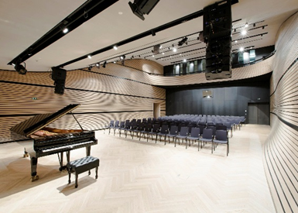
Fig. 1: A Zumtobel lighting solution sets the arlberg1800 Contemporary Art and Concert Hall in the best possible light.
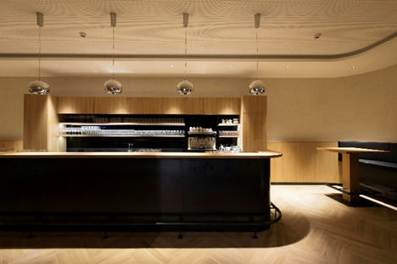
Fig. 2: The SCONFINE decorative pendant designed by Matteo Thun plays with the effects of form, light and space in the bar area.
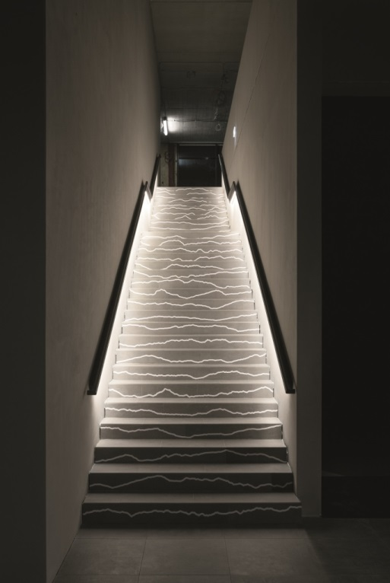
Fig. 3: Functional luminaires provide orientation and a pleasant ambience in the entrance and hallways.
Press contact:
Zumtobel Lighting GmbH
Sophie Moser
Head of Brand Communications
Schweizer Strasse 30
6850 Dornbirn
Austria

Tel: +43 5572 390 26527
Mobil: +43 664 80892 3074
press@zumtobel.com

www.zumtobel.com

Responsible sales office:
ZG Lighting Austria GmbH
Beratungszentrum Dornbirn
Millennium Park 20/4
6890 Lustenau
Austria

Tel: +43 5572 390-162
Fax: +43 5572 390-378
bzdornbirn@zumtobel.at

www.zumtobel.at
Sales contact:
Zumtobel Lighting Ltd.  Chiltern Park  Chiltern Hill, Chalfont St Peter  Buckinghamshire SL9 9FG  United Kingdom  Tel: +44 1753 482 650  Fax: +44 1753 480 350  uksales@zumtobel.com  www.zumtobel.co.uk | Zumtobel Lighting Inc.  3300 Route 9  Highland , NY 12528  United States  Tel: +1 845 691 6262  Fax: +1 845 691 6289  zli.us@zumtobelgroup.com  www.zumtobel.us

For further contact details in further sales regions please visit: http://www.zumtobel.com/com-en/contact.html

About Zumtobel
Zumtobel, a leading international supplier of integral lighting solutions, enables people to experience the interplay of light and architecture. As a leader in innovation, Zumtobel provides a comprehensive range of high-quality luminaires and lighting management systems for professional interior lighting in the areas of offices, education, presentation & retail, hotel & wellness, health, art & culture as well as industry. Zumtobel is a brand of Zumtobel Group AG with its head office in Dornbirn, Vorarlberg (Austria).
Zumtobel. The Light.

