Press release

Comparison of lighting solutions
Quick, reliable and transparent evaluation of lighting solutions by Zumtobel's ecoCALC light
Dornbirn, July 2015 – Knowing at a glance what is the difference between various lighting solutions in terms of quality, efficiency and costs, and how quickly a new system will pay off – this is made possible by Zumtobel's calculation programme ecoCALC. Evaluations can now be obtained even faster by using the programme's simplified version: ecoCALC light.
The entries required to perform a calculation have been reduced to a minimum, so that up to three lighting solutions can be compared on site in just a few steps. Without having to install any software, you may use ecoCALC light on your computer or, in the mobile version, directly on your tablet PC. The costs that will be incurred for every lighting solution across its entire service life and the resulting payback times will become obvious very quickly. Not only the investment costs, but also energy consumption, maintenance costs and CO₂ emissions are collected and documented. The ecoCALC light programme helps customers understand at once the evaluation of a new lighting solution in terms of both quality and quantity. Integral cost calculation provides the necessary transparency for customers to be able to make a decision resulting in measurable added value.
Access to the web-based programme is possible via the following link free of charge at any time. Just a few clicks are all it takes to configure and compare various lighting solutions based on existing luminaires included in Zumtobel's online catalogue.

Captions:
(Photo credits: Zumtobel)

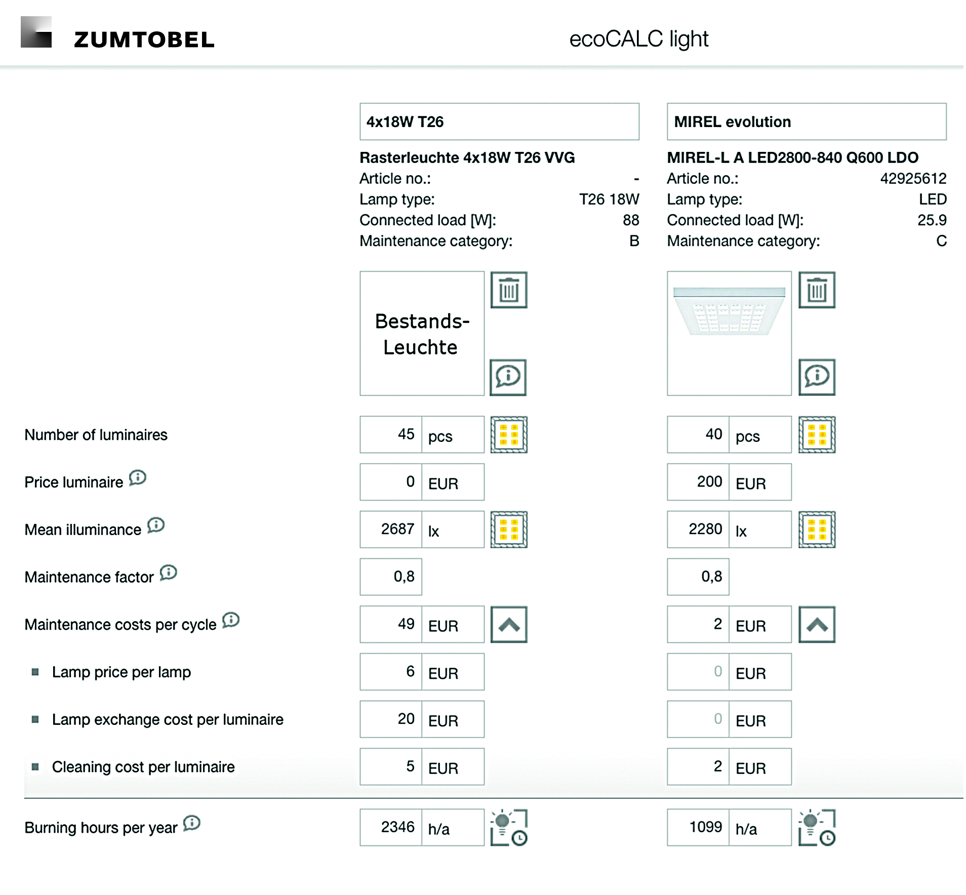
Fig. 1: The web-based ecoCALC light programme boasts an intuitive input screen. Prices are examples only.
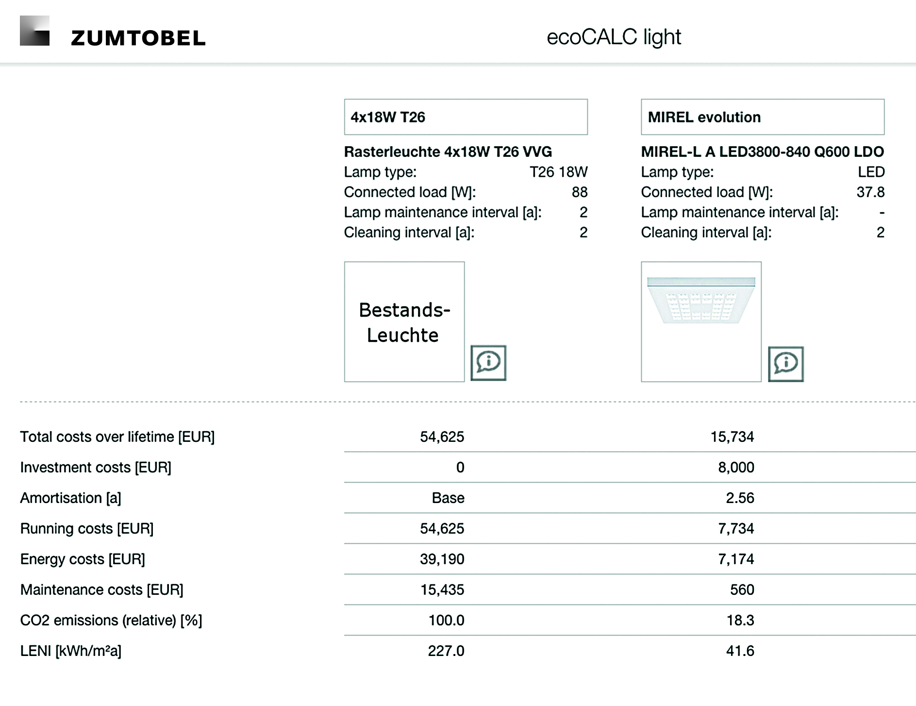
Fig. 2: ecoCALC light compares lighting solutions according to criteria based on quality and quantity in a clearly structured manner.
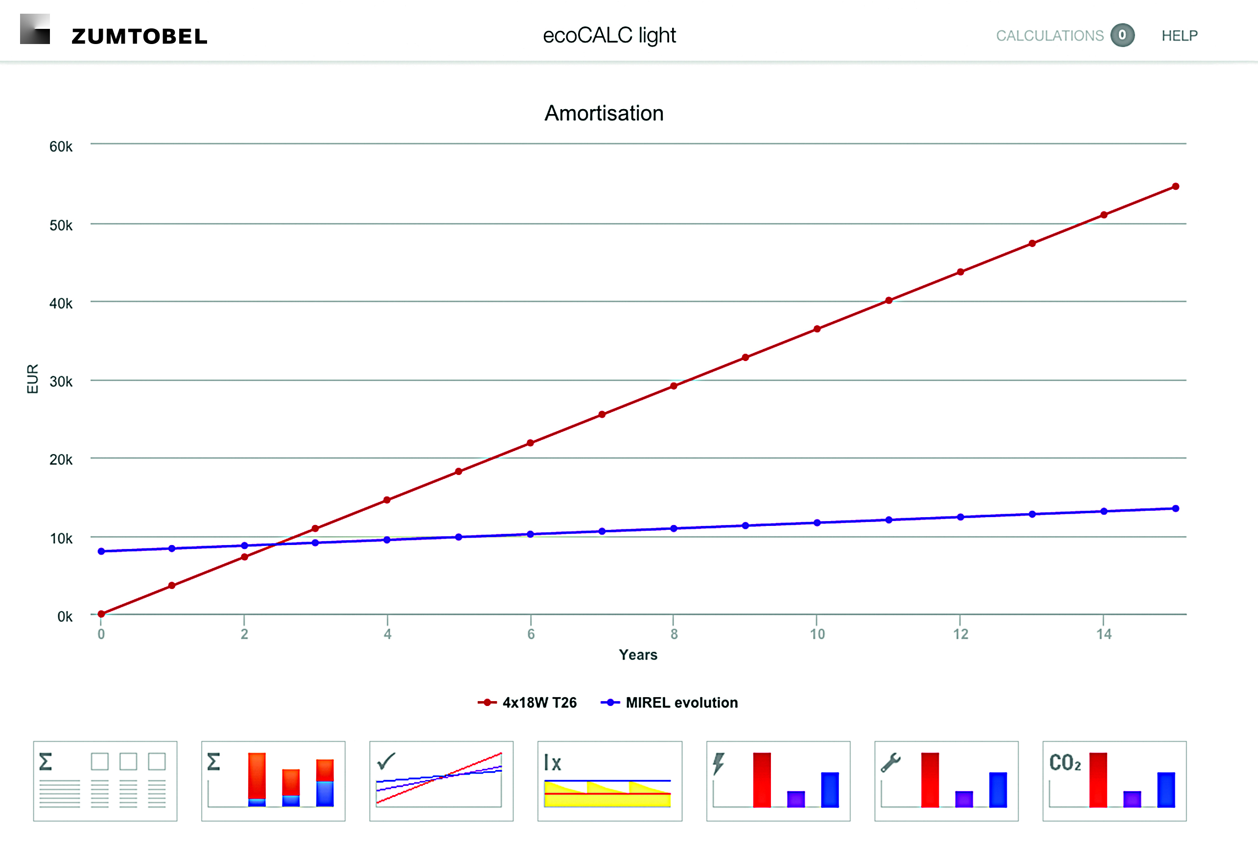
Fig. 3: Pre-programmed visualisations are available as well – here, for example, you can see how the new lighting solution will pay off over the years.

Press contact:
Zumtobel Lighting GmbH
Sophie Moser
Head of Brand Communications
Schweizer Strasse 30
6850 Dornbirn
Austria

Tel: +43 5572 390 26527
Mobil: +43 664 80892 3074
press@zumtobel.com

www.zumtobel.com

Sales contact:
Zumtobel Lighting Ltd.  Chiltern Park  Chiltern Hill, Chalfont St Peter  Buckinghamshire SL9 9FG  United Kingdom  Tel: +44 1753 482 650  Fax: +44 1753 480 350  uksales@zumtobel.com  www.zumtobel.co.uk | Zumtobel Lighting Inc.  3300 Route 9  Highland , NY 12528  United States  Tel: +1 845 691 6262  Fax: +1 845 691 6289  zli.us@zumtobelgroup.com  www.zumtobel.us

For further contact details in further sales regions please visit: http://www.zumtobel.com/com-en/contact.html

About Zumtobel
Zumtobel, a leading international supplier of integral lighting solutions, enables people to experience the interplay of light and architecture. As a leader in innovation, Zumtobel provides a comprehensive range of high-quality luminaires and lighting management systems for professional interior lighting in the areas of offices, education, presentation & retail, hotel & wellness, health, art & culture as well as industry. Zumtobel is a brand of Zumtobel Group AG with its head office in Dornbirn, Vorarlberg (Austria).
Zumtobel. The Light.

