Press release

CRAFT S: Compact powerhouse
The latest addition to the successful CRAFT product family is a smaller version of the high-bay LED luminaire. With a luminous flux of 7500 lumens and a Luminaire Efficiency Factor of 115 lm/W, CRAFT S proves itself to be a real compact powerhouse.
Dornbirn, May 2015 – CRAFT S is the ideal solution for all lighting tasks in industry applications with a ceiling height of 4-8 metres, measuring only 338mm × 165mm × 100mm. The new miniaturised S version has the same patented aluminium housing design as the existing CRAFT family, incorporating cooling fins for optimal thermal management. This creates a flow of air through the luminaire to ensure passive cooling and thereby prolong the lifetime of the LEDs – even at higher temperatures. At the same time, this airflow helps prevent dust gathering on the luminaire, which leads to lower maintenance costs and is particularly beneficial when the product is mounted in areas that are difficult to access. IP65 protection, the ability to cope with higher ambient temperatures and resistance to chemical substances further emphasise the maximum staying power of this miniature luminaire.
The PMMA optic delivers targeted and efficient lighting. The existing colour temperature range of 4000 K and 6500 K is supplemented by a warm white version with 3000 K, making CRAFT S an interesting option for shop and retail applications. Installation on TECTON continuous-row lighting system is now even easier, thanks to the introduction of a CRAFT S variant delivered with a pre-installed TECTON mounting mechanism.

CRAFT S utilises the innovative lighting technology from the existing CRAFT range to ensure excellent light distribution. High rows of shelves can be illuminated just as efficiently as large open spaces. Thanks to the separate wide beam and narrow beam lens optics, this luminaire offers exactly the right solution for every industry application. The narrow beam optic was specially engineered to deliver uniform and efficient lighting for long areas of high shelving. As each LED has been assigned its own lens, the light output can be carefully directed to ensure precise illumination, excellent visual comfort and high efficiency. The wide beam optic was optimised for open production areas, where glare control and uniformity are particularly important.

Photo captions:
(Photo credits: Zumtobel)
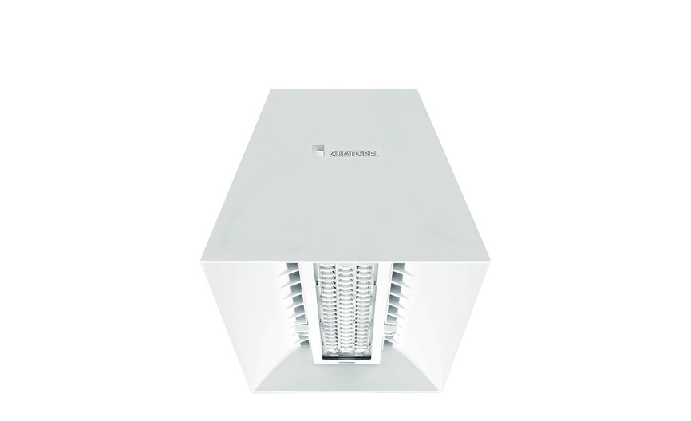
Photo 1: The new miniaturised S version has the same patented aluminium housing design as the existing CRAFT family, incorporating cooling fins for optimal thermal management.
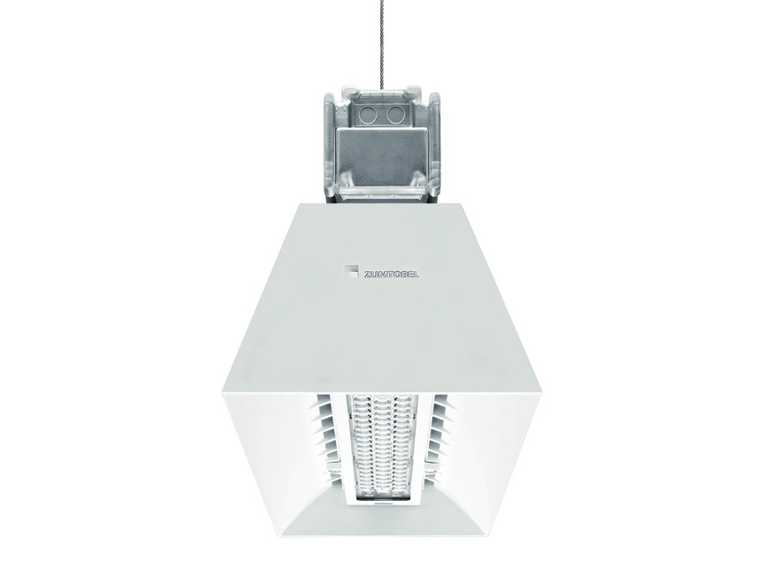
Photo 2: CRAFT S is available to order with a pre-installed TECTON mounting mechanism.

Press contact:
Zumtobel Lighting GmbH
Sophie Moser
PR Manager
Schweizer Strasse 30
A-6850 Dornbirn

Tel +43-5572-390-26527
Mobil +43-664-80892-3074
E-Mail press@zumtobel.com
www.zumtobel.com

Sales contact:
Zumtobel Lighting Ltd.  Chiltern Park  Chiltern Hill, Chalfont St Peter  Buckinghamshire SL9 9FG  United Kingdom  Tel: +44 1753 482 650  Fax: +44 1753 480 350  uksales@zumtobel.com  www.zumtobel.co.uk | Zumtobel Lighting Inc.  3300 Route 9  Highland , NY 12528  United States  Tel: +1 845 691-6262  Fax: +1 845 691-6289  zli.us@zumtobelgroup.com  www.zumtobel.us

For further contact details in further sales regions please visit: http://www.zumtobel.com/com-en/contact.html

About Zumtobel
Zumtobel, a leading international supplier of integral lighting solutions, enables people to experience the interplay of light and architecture. As a leader in innovation, Zumtobel provides a comprehensive range of high-quality luminaires and lighting management systems for professional interior lighting in the areas of offices, education, presentation & retail, hotel & wellness, health, art & culture as well as industry. Zumtobel is a brand of Zumtobel Group AG with its head office in Dornbirn, Vorarlberg (Austria).
Zumtobel. The Light.

