Press release

Lech illuminated
Zumtobel implements custom solution to illuminate the town of Lech am Arlberg
This winter, night-time appearance of the ski resort of Lech has been changed by a newly implemented LED lighting concept. In collaboration with Dieter Bartenbach, Zumtobel has developed a custom solution which skilfully illuminates not only the townscape of Lech, but also the river of the same name. A specifically developed control system adjusts the lighting levels depending on the time of day or night, so that the lighting conditions will be perfect at all times.
Dornbirn, March 2015 – Lech am Arlberg in Austria is a picture-postcard skiing location, picturesquely situated on the banks of the river Lech, surrounded by an impressive mountain scenery, up to 2809 m above sea level. The small town of approximately 1500 inhabitants lives on tourism: with some 8300 hotel beds available, Lech reports almost one million overnight stays per year. The town has been preserved as a smallish village settlement and makes very high demands on itself. For instance, Lech was distinguished with the title “most beautiful village in Europe” in the past.
Thanks to the new lighting concept developed by Dieter Bartenbach and implemented in close collaboration with Zumtobel, the town is now presented in perfect light. “The existing street lighting system with its obsolete technology was simply not up to contemporary requirements any more,” remembers Karlheinz Egger from the Lech building authority. However, it took many meetings and information events as well as a lot of persuading to win over political decision-makers, administrators and the local hotel keepers to opt for a new lighting concept based on LED technology.
The situation that Dieter Bartenbach was facing when he started his planning work was the same he finds again and again at other locations: a “lighting mess” that “blurs” the townscape. The diffuse lighting situation is usually caused by conventional outdoor lighting mostly involving lamps with open light distribution. This is countered by the illumination of shop windows and advertising facilities through highly excessive light radiation, which makes the original townscape disappear completely. “The perception of space is overturned in that the attention of the viewer is drawn exclusively to the sources of glare,” Bartenbach explains.
The new concept ensures that the nightly townscape of Lech with its typical features is deliberately highlighted by LED lighting which provides accent lighting and defines spaces. The luminaire especially manufactured for this purpose dissolves the lighting intensity into several LED points, so that passers-by are hardly dazzled any more. Additionally, the light is much more precise and directional than before. This is achieved through precise milling of the LED lighting points. Another benefit is the modular design, similar to a system of building blocks: the luminaires can be configured with 6 to 34 LED points, each with approx. 2 W. Thus, the lighting situation can be adjusted as required. For the columns, too, Zumtobel has developed various different versions depending on the location.
It is primarily the linear alignment of spaces that is characteristic of the village and is emphasised through the new lighting solution: the main street, which is pleasantly illuminated in the way of an esplanade, the house façades and the river. Making the river perceptible within the nocturnal townscape was considered especially important by the planners. The lighting brings the river back into the town by illuminating the banks and walls. Both are reflected along the water course and make for a dynamic image captivating the viewer through the movement of the current, so that a three-dimensional effect is created. Another spatial element is the illumination of the façades. Here, the modular system proves particularly beneficial. Instead of installing the luminaire heads on the columns, they can also be installed on the façades, thus not only providing for uniformity of appearance and a balanced lighting effect but also for spectacular illumination of the hotel façades. This argument eventually convinced the hotel keepers, who are themselves responsible for financing these measures.
The new lighting is dispensed in a well-dosed manner: from dusk till 10 p.m., all spaces of the town are illuminated. After 10 p.m., façade illumination is switched off. At midnight, the brightness of the street lighting is reduced to a low ambient lighting level. The finely tuned brightness levels are made possible by special, web-based lighting control: each luminaire contains a radio sensor that is used for dimming and switching the light. In this way, the idea of the Smart City is introduced into the alpine landscape of Vorarlberg.
The new town lighting is therefore not only a visual improvement. Precise focussed light combined with effective glare reduction and lighting control ensures that the town is illuminated in a sustainable manner. The LED luminaires used are more efficient and environmentally compatible than conventional diffuse lighting concepts with open light distribution, which emit 60 per cent of the light into the sky with no effect. In addition, light pollution and the impact of light on animals are reduced as well. Lech's new nightly townscape is therefore an investment into the future in many respects.

Client: Municipality of Lech am Arlberg, Lech am Arlberg/A
Lighting design: Dieter Bartenbach, Innsbruck/A
Electrical installations: Elektro Müller, Landeck/A
Lighting solution: Custom lighting solution

Captions:
(Photo credits: Zumtobel)
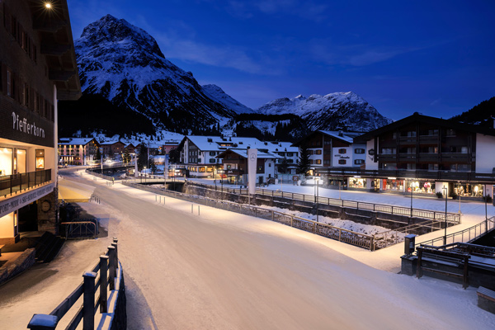
Fig. 1: The town of Lech am Arlberg shines in a new light.
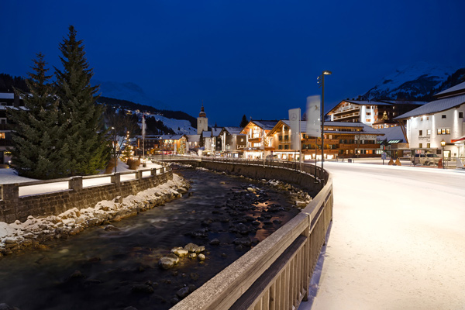
Fig. 2: The river of the same name is reintegrated into the townscape by the new lighting system.
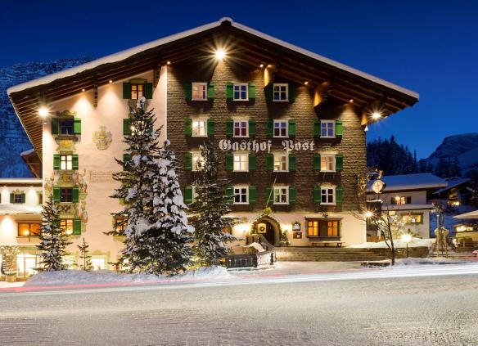
Fig. 3: The façades of the traditional buildings are enhanced by the new lighting concept.
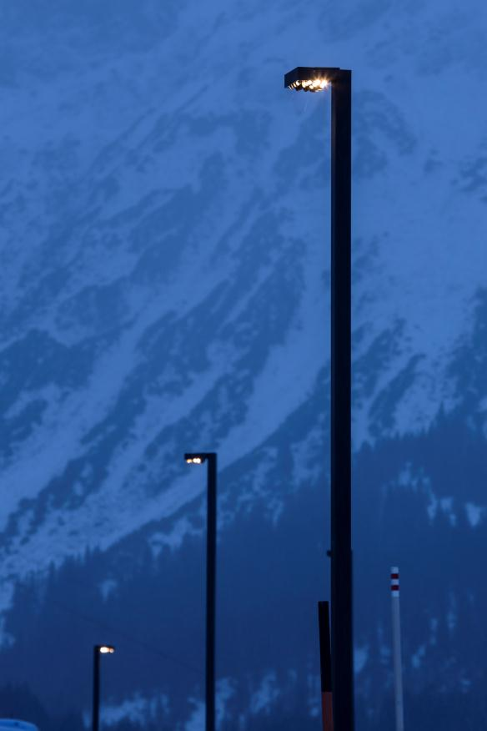
Fig. 4: The luminaires can be configured with 6 to 34 LED points, each with approx. 2 W.
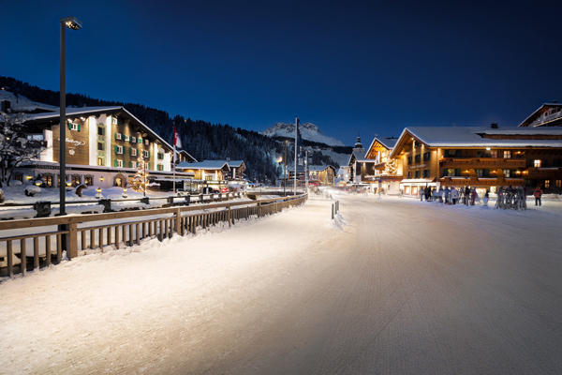
Fig. 5: It is primarily the linear alignment of spaces that is characteristic of the village and is emphasised through the new lighting solution: the main street, which is pleasantly illuminated in the way of an esplanade, the house façades and the river.

Press contact:
Zumtobel Lighting GmbH
Sophie Moser
PR Manager
Schweizer Strasse 30
A-6850 Dornbirn

Tel +43-5572-390-26527
Mobile: +43-664-80892-3074
E-mail press@zumtobel.com
www.zumtobel.com

Sales contact:
Zumtobel Lighting Ltd.  Chiltern Park  Chiltern Hill, Chalfont St Peter  Buckinghamshire SL9 9FG  United Kingdom  Tel: +44 1753 482 650  Fax: +44 1753 480 350  uksales@zumtobel.com  www.zumtobel.co.uk | Zumtobel Lighting Inc.  3300 Route 9  Highland , NY 12528  United States  Tel: +1 845 691-6262  Fax: +1 845 691-6289  zli.us@zumtobelgroup.com  www.zumtobel.us

For further contact details in further sales regions please visit: http://www.zumtobel.com/com-en/contact.html

About Zumtobel
Zumtobel, a leading international supplier of integral lighting solutions, enables people to experience the interplay of light and architecture. As a leader in innovation, Zumtobel provides a comprehensive range of high-quality luminaires and lighting management systems for professional interior lighting in the areas of offices, education, presentation & retail, hotel & wellness, health, art & culture as well as industry. Zumtobel is a brand of Zumtobel AG with its head office in Dornbirn, Vorarlberg (Austria).
Zumtobel. The Light.

