Press information

Light exactly where you need it
LINETIK free-standing LED luminaire focuses on the essentials

Dornbirn, February 2015 – Designers and engineers set about challenging every aspect of office lighting during the development of the new LINETIK free-standing LED luminaire. The result is a pioneering product that uses minimal resources to provide maximum visual comfort for every workplace. Design elements carefully crafted to focus on the core essentials deliver an elegant appearance, free from superfluous details.
LINETIK stands out from the office lighting crowd with a delicate design language. Despite its distinctive look, this free-standing luminaire can be integrated effortlessly into any office environment. Even more amazing is the fact that the slim body, at 24 x 24 mm cross section, and compact base conceal a revolutionary lighting concept: light exactly where the user needs it. "The requirements for LINETIK were clear. Ensure the best lighting technology in the smallest space, delivering light that can be individually controlled by the user," says Sebastian Schubnell, Zumtobel Project Manager for Future Lighting Solutions, about the idea behind this innovative LED luminaire.
Zumtobel found the right partners for this ambitious project in three designers - Simon Fisher and Matt Free from F Mark Ltd and Luke Smith-Wightman. "We have questioned absolutely everything – from existing lighting solutions to the way offices are designed. The unique shape of LINETIK grew out of a desire to really only use what is needed," explains Matt Free, Director at Mark F Ltd.
A radical approach that focuses on the real essentials - the best light for every task in every workplace for every employee. No stone was left unturned in the development of a new optical system to achieve this target. Despite the compact physical dimensions, the optical system had to use minimal energy to deliver a precise lighting distribution – light that is directed exactly where the individual requires it, without the inconvenience of glare and anything less than complete uniformity.
One significant outcome of this tireless pursuit of lighting technology innovation is the newly developed reflector, which significantly contributes to the drastic reduction in the material footprint of the product. In order to create a reflector with such compact dimensions, without compromising key elements such as glare control and lighting distribution, the development team opted to use reflector modules. A series of fully-automated high-precision tools inject a special composite material that is then vapour-coated with highly reflective aluminium.
The reflector for the direct light output delivers exceptionally uniform illumination over the workplace, especially when compared to other free-standing solutions. In the longitudinal direction, light is directed asymmetrically onto the work surface, whilst in the transverse direction, a type of double asymmetry is achieved to ensure a balanced distribution for workplaces with two people. LINETIK relies on an extrusion lens for the indirect output, spreading light over a wide ceiling area and thereby creating a pleasant atmosphere, even in offices with lower ceilings.
The slim silhouette of LINETIK belies a robust product that is easily assembled and positioned anywhere in the room. Direct and indirect lighting elements can be individually controlled, ensuring optimum visual comfort for every task. In addition an integral motion sensor ensures the luminaire is off when workers are absent.

LINETIK - facts and figures
Dimensions: H: 2224 mm
L: 1240 mm
Cross-section: 24 mm x 24 mm
Mounting: Free-standing luminaire
Housing: Aluminium profile
Connected load: 56 W
Luminaire efficiency: 107 lm/W
Luminaire luminous flux: 6000 lm
Colour temperature: 3000 K / 4000 K
Colour rendering: Ra > 80
Controls: Ambient light dependent control and presence detection

Photo captions:
(Photo credits: Zumtobel)

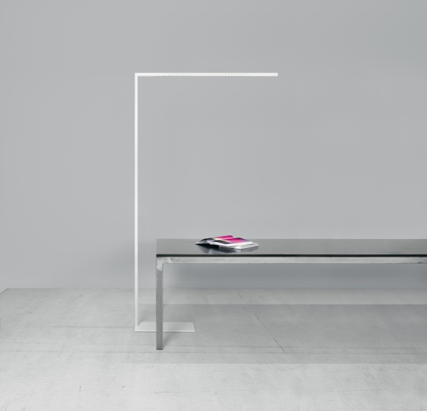
Photo 1: LINETIK questions all classical principles of office lighting – but still integrates perfectly in every office setup.
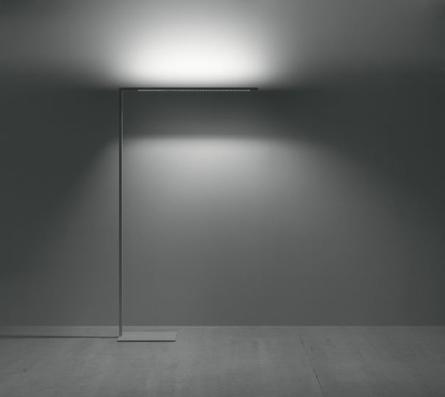
Photo 2: Direct and indirect lighting elements can be individually controlled, ensuring optimum visual comfort for every task.
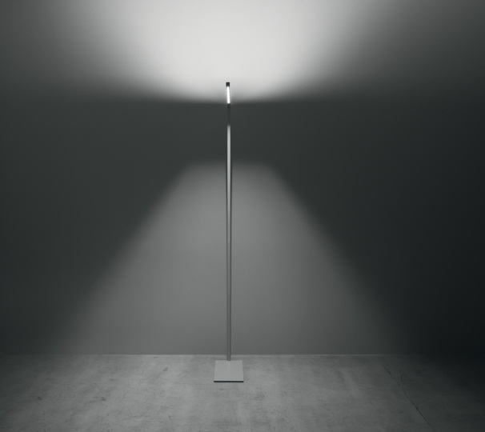
Photo 3: The reflector for the direct light persuades with exceptionally uniform illumination over a workplace, even over workplaces with two people.
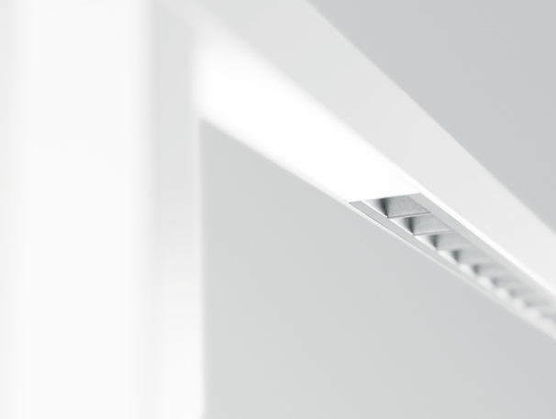
Photo 4: Despite of its minimalistic design, the novel reflector allows uncompromised glare and completely uniform light distribution.
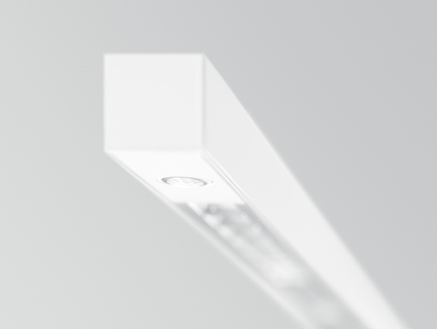
Photo 5: The slim body, at 24 mm x 24 mm cross section, and compact base conceal a revolutionary lighting concept.

Press contact information:
Zumtobel Lighting GmbH
Sophie Moser
PR Manager
Schweizer Strasse 30
A-6850 Dornbirn

Tel +43-5572-390-26527
Mobil +43-664-80892-3074
E-Mail press@zumtobel.com
www.zumtobel.com

Sales contact:
Zumtobel Lighting Ltd.  Chiltern Park  Chiltern Hill, Chalfont St Peter  Buckinghamshire SL9 9FG  United Kingdom  Tel: +44 1753 482 650  Fax: +44 1753 480 350  uksales@zumtobel.com  www.zumtobel.co.uk | Zumtobel Lighting Inc.  3300 Route 9  Highland , NY 12528  United States  Tel: +1 845 691-6262  Fax: +1 845 691-6289  zli.us@zumtobelgroup.com  www.zumtobel.us

For further contact details in further sales regions please visit: http://www.zumtobel.com/com-en/contact.html

About Zumtobel
Zumtobel, a leading international supplier of integral lighting solutions, enables people to experience the interplay of light and architecture. As a leader in innovation, Zumtobel provides a comprehensive range of high-quality luminaires and lighting management systems for professional interior lighting in the areas of offices, education, presentation & retail, hotel & wellness, health, art & culture as well as industry. Zumtobel is a brand of Zumtobel AG with its head office in Dornbirn, Vorarlberg (Austria).
Zumtobel. The Light.

